**Fanka Shundovska**

**POSTMAN Extra Homework**

In Postman:

We are going to execute and write tests from the store section in Petstore swagger with the following order.

* **POST**/store/order, write test for all json property that we get in the response(Note: when you insert id just pick a number from 1 to 10)

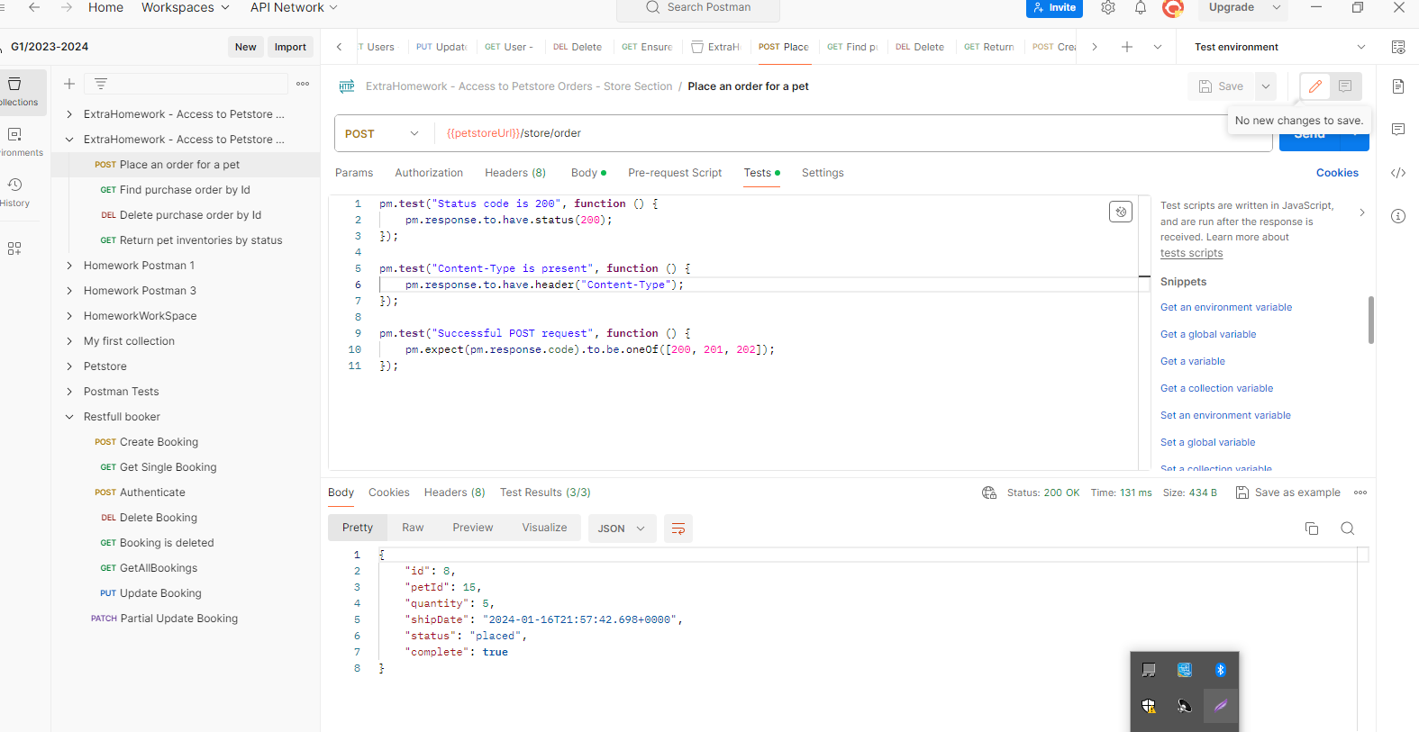

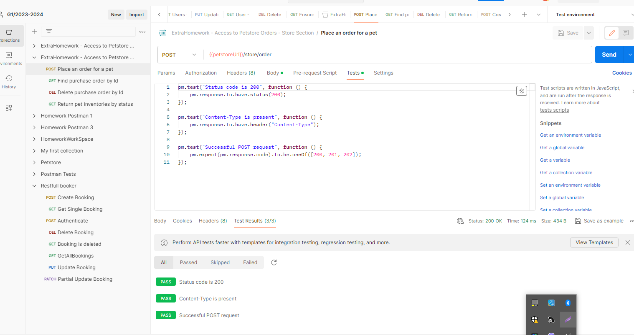

* **GET**/store/order/{orderId}: write test for all json property as well as status code, response time(bellow 4 seconds).

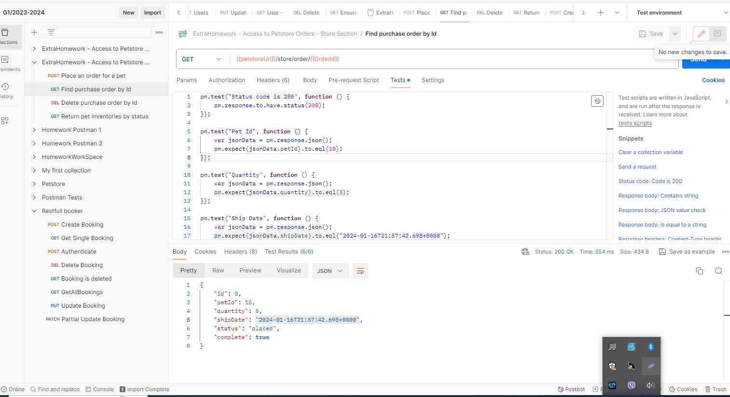

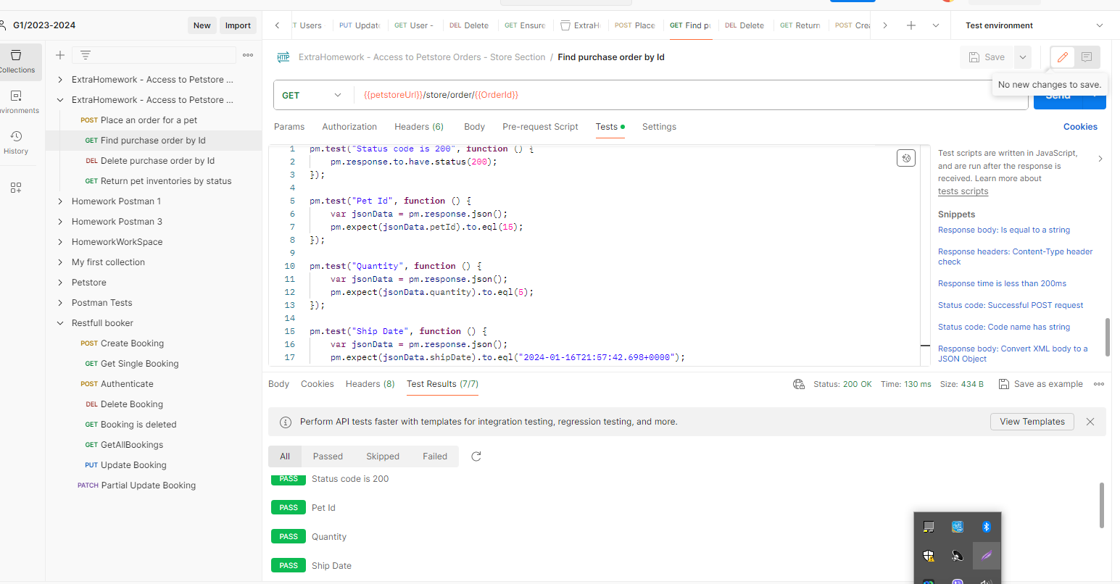

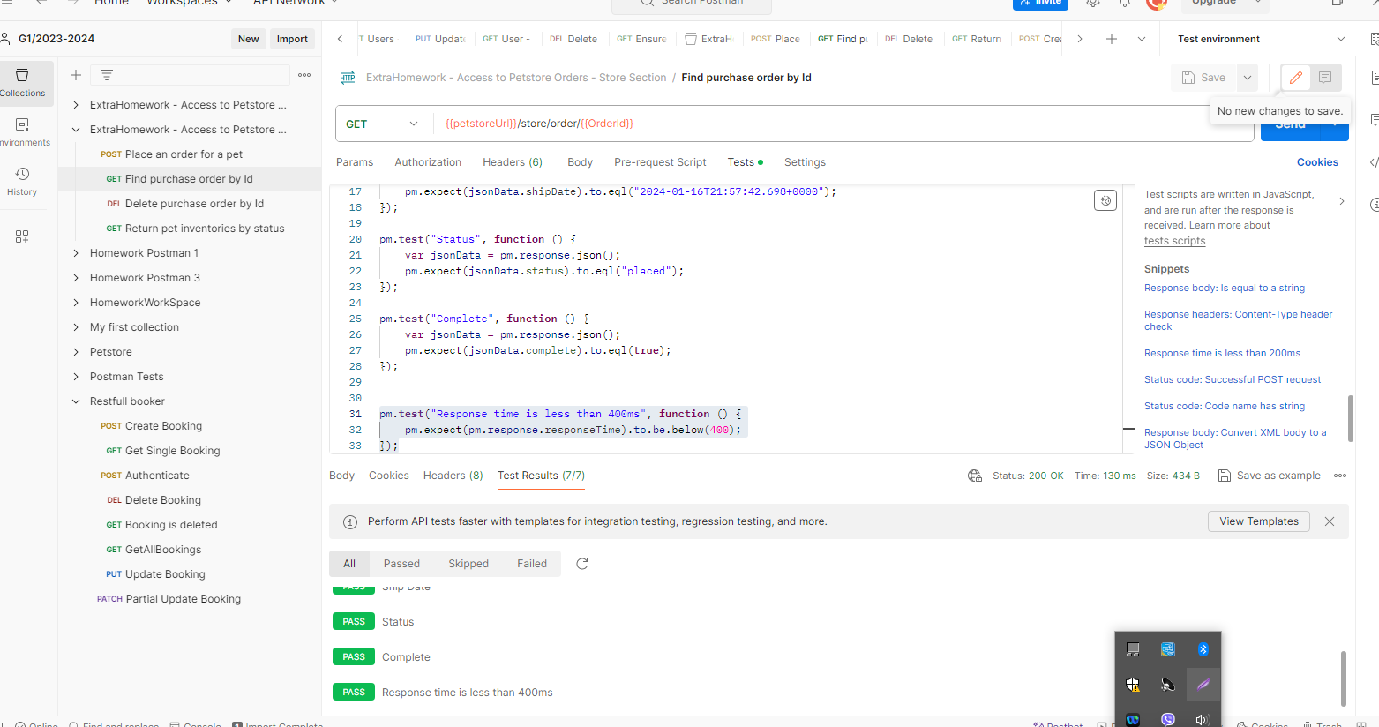

* **DELETE**/store/{orderId}: write tests for status code and for json property only if it's returning non-dynamic values.

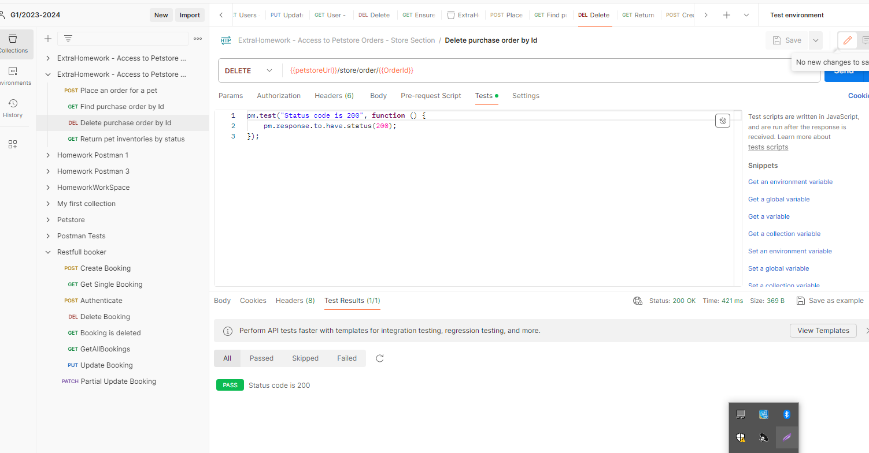

* **GET**/store/order/{orderId}: Write test to check the status code that no order has been found.

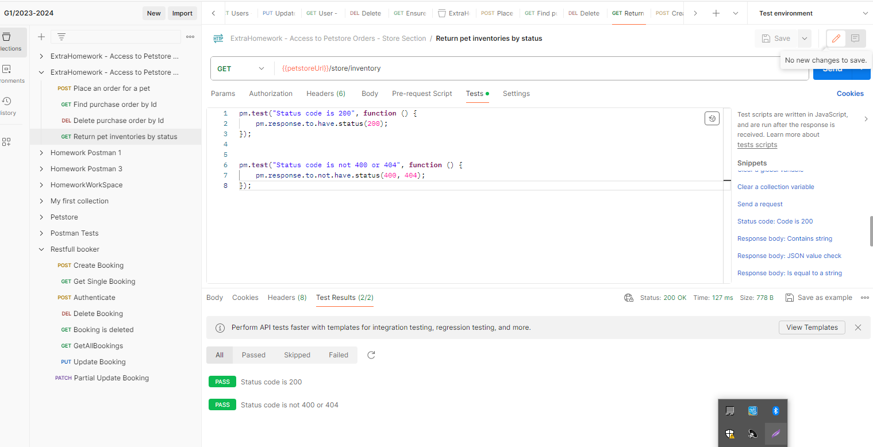

* **GET**/store/inventory: Write test to check if it's returning status code is 200 or 201, and test that we don't receive status code 404 or 400.

